Additional file 2: Ovid MEDLINE search
Search conducted on Ovid MEDLINE(R), Ovid MEDLINE(R) Daily and Epub Ahead of Print, In-Process & Other Non-Indexed Citations 1946 to Present.
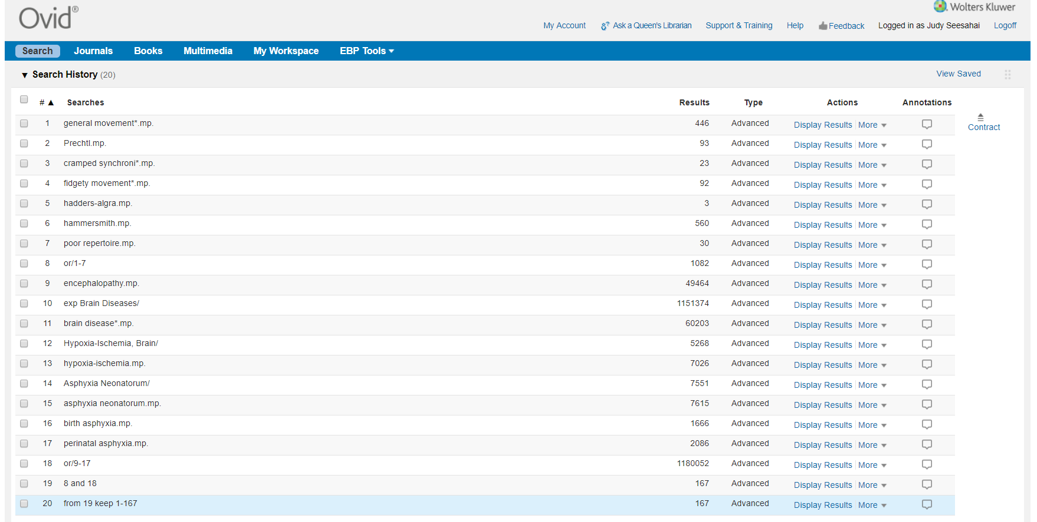
Search conducted on May 22nd, 2019.

